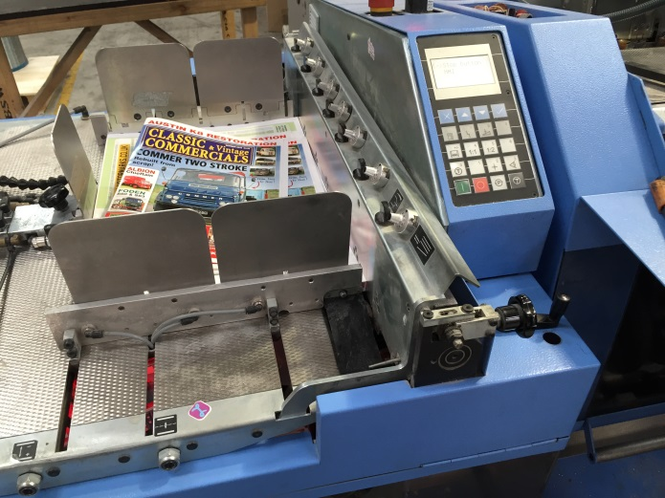
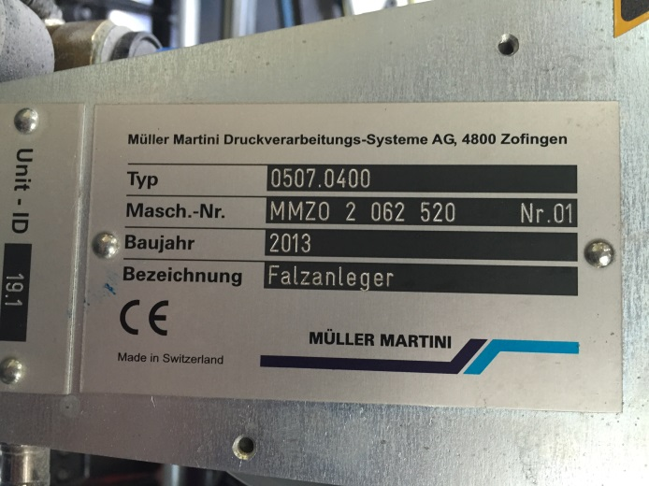
Muller 0507 Cover Feeder

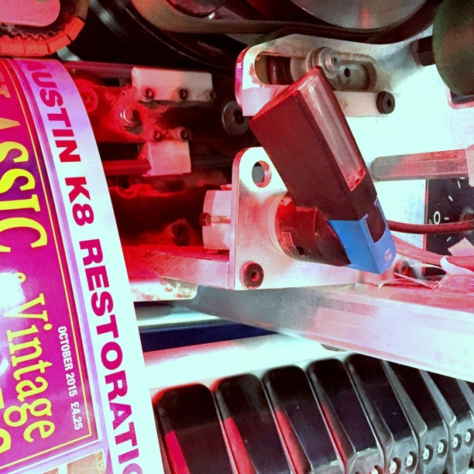

To raise the metal creasing score wheel from the cylinder drum turn off the air valve.

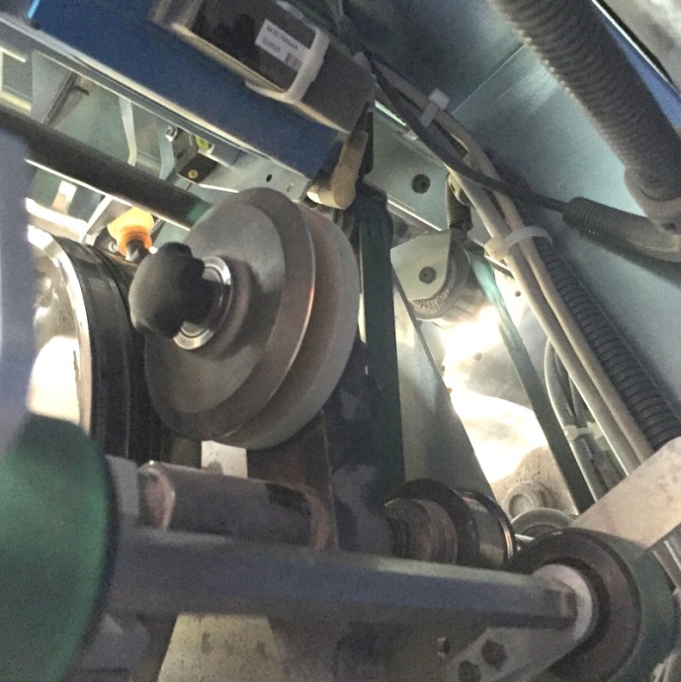
After the air activated creasing score wheel is removed from the cylinder drum the black knob holding the metal score wheel can be removed.
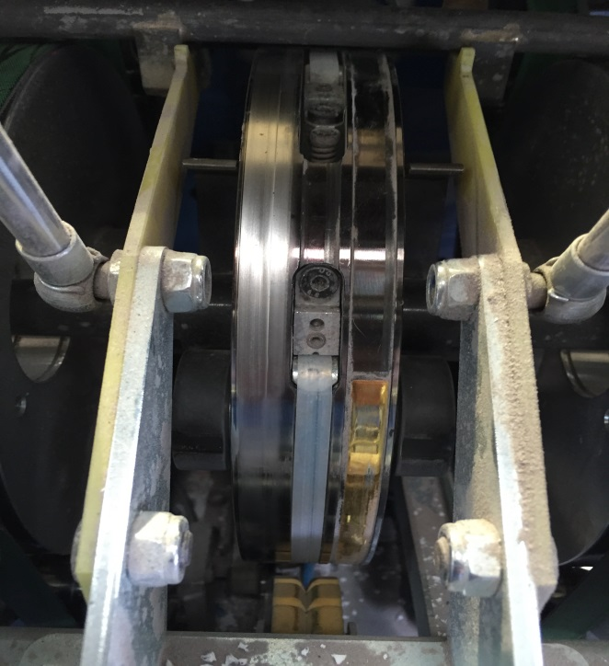
Remove the 2 screws that hold the white plastic matrix.

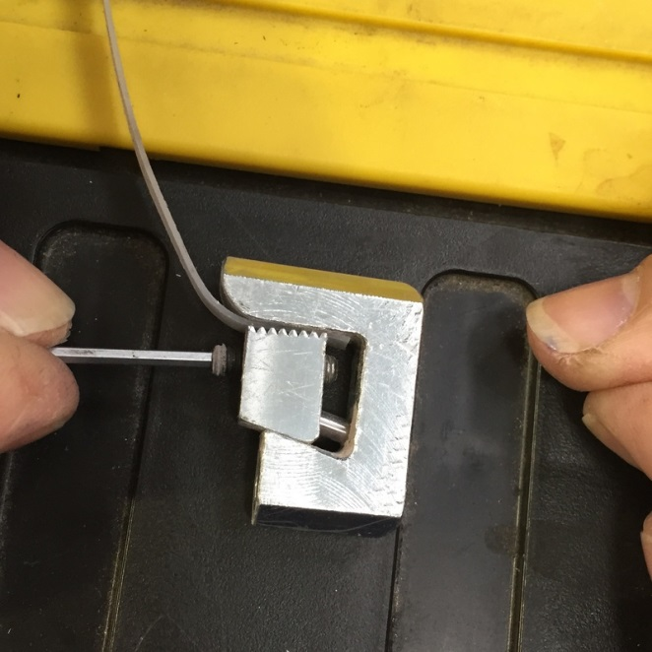
Unscrew the matrix holding screws from the 2 matrix holders and renew with the supplied colour-coded black creasing matrix making sure the creasing protrusion is facing outwards. Retighten the matrix holding screws.
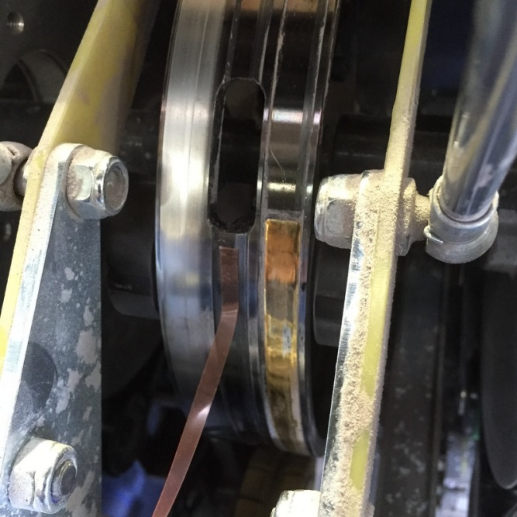

Apply the 4mm wide red adhesive tape to the outer diameter of the cylinder drum. Position the tape as shown.

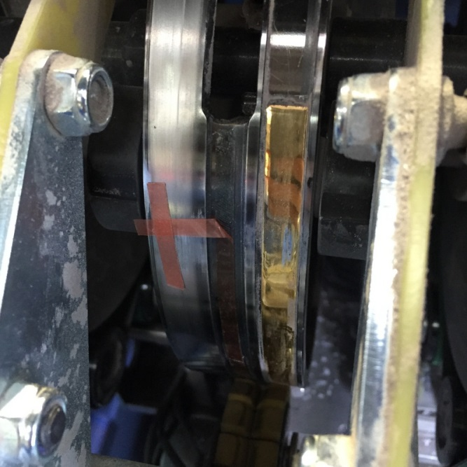
Peel back 25mm of the red 2-sided adhesive tape and secure at 90 degrees as shown in photo.
This helps to secure the creasing matrix at a later stage of the installation.

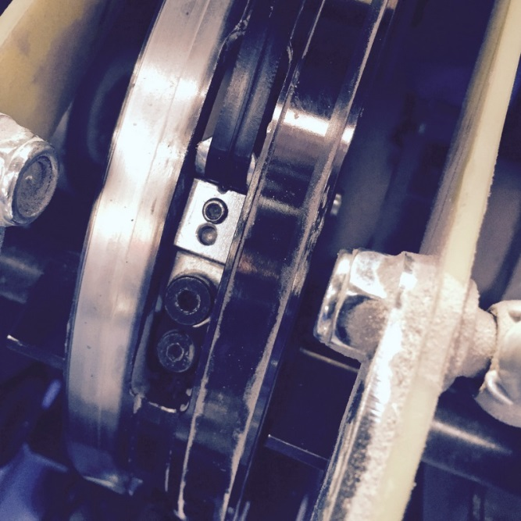

Push in the matrix holding units and secure with the fixing screws.

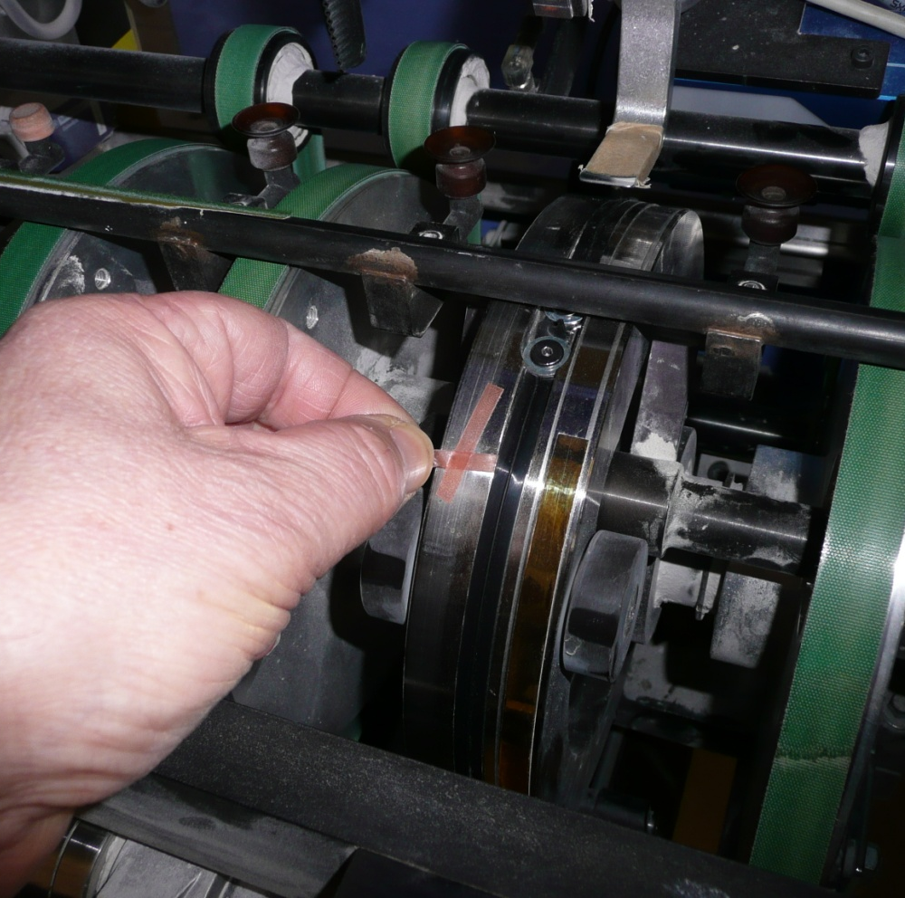
To adhere the 2 sided adhesive to the matrix please pull away the protective cover.

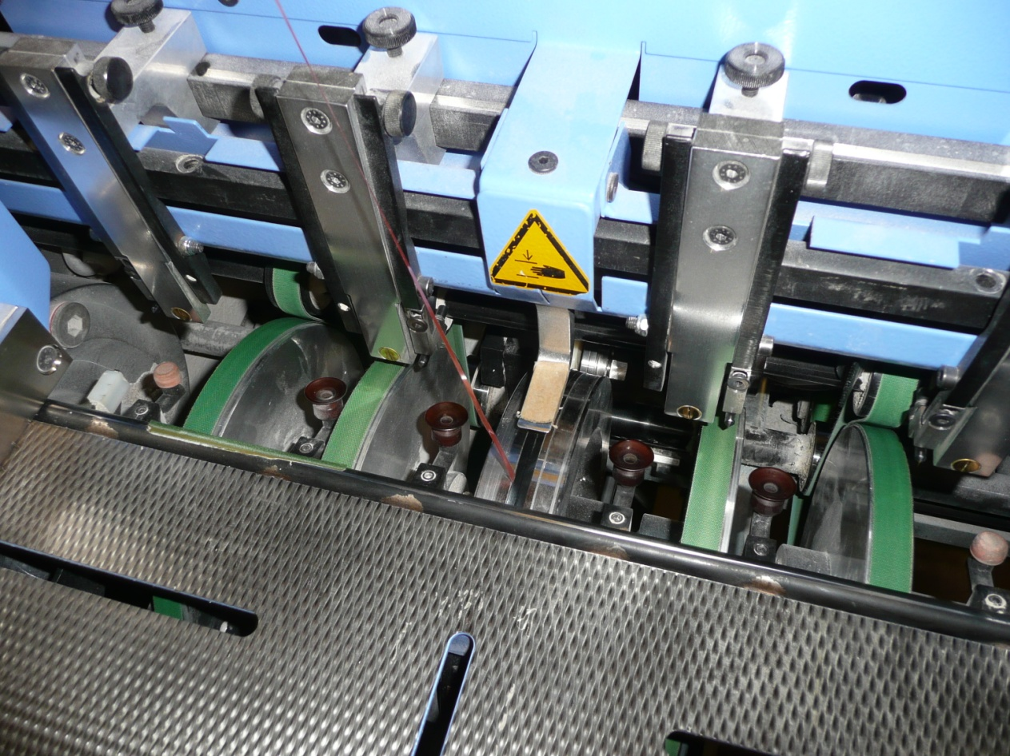
The protective adhesive strip being pulled away from under the creasing matrix.

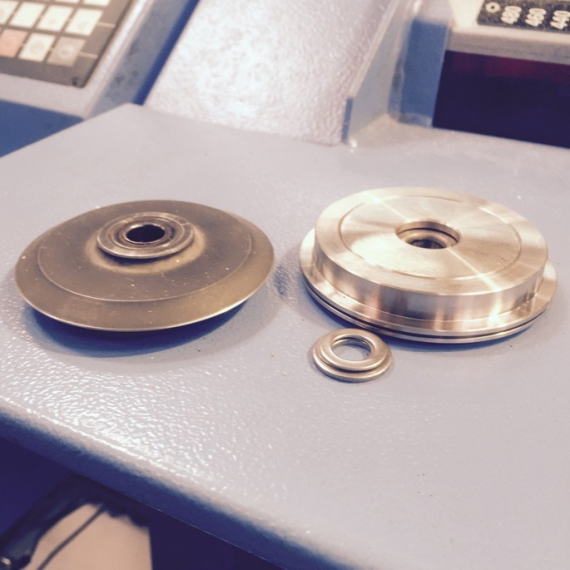
There are several thicknesses of spacing washers that are included in the installation pack.

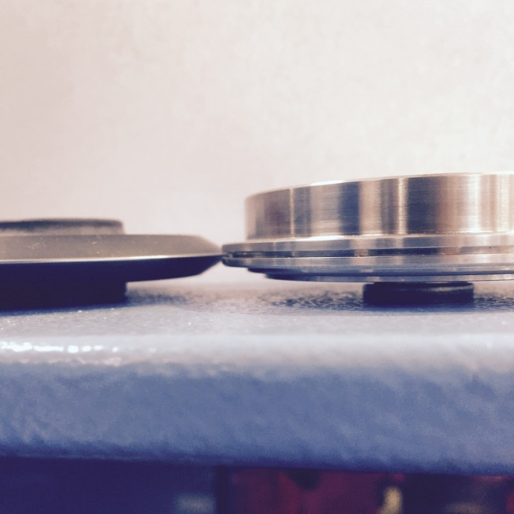
The spacers are placed under the new female until the centre of the female channel is aligned with the original scoring position.
Place the required washers onto the pressure shaft before sliding on the female and holder.

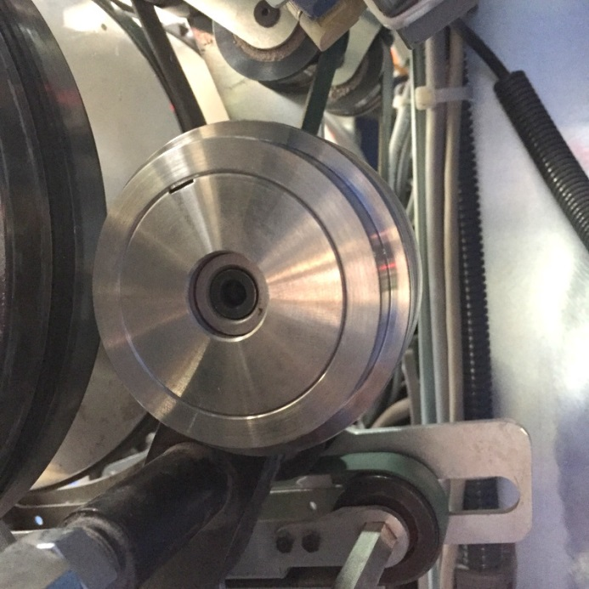
There are 3 widths of colour coded females. The colour code is found on the outer diameter of the female. Select the desired female and slide it onto the holder and tighten using the supplied hexagon key.
1x Orange Dot Female:
Creases between 100-135gsm

1x White Dot Female:
Creases between 120-300gsm

1x Yellow Dot Female:
Creases between 250-350gsm

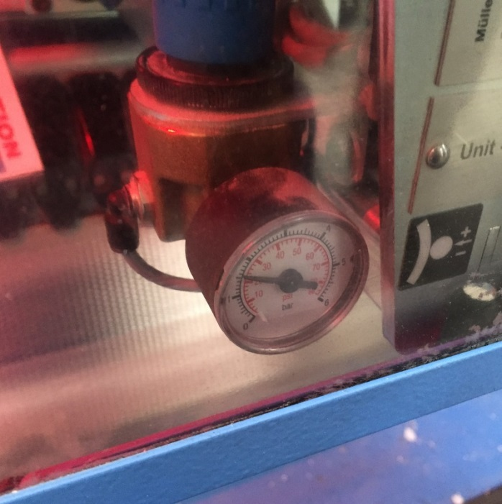

Reduce the air pressure to the pressure shown.

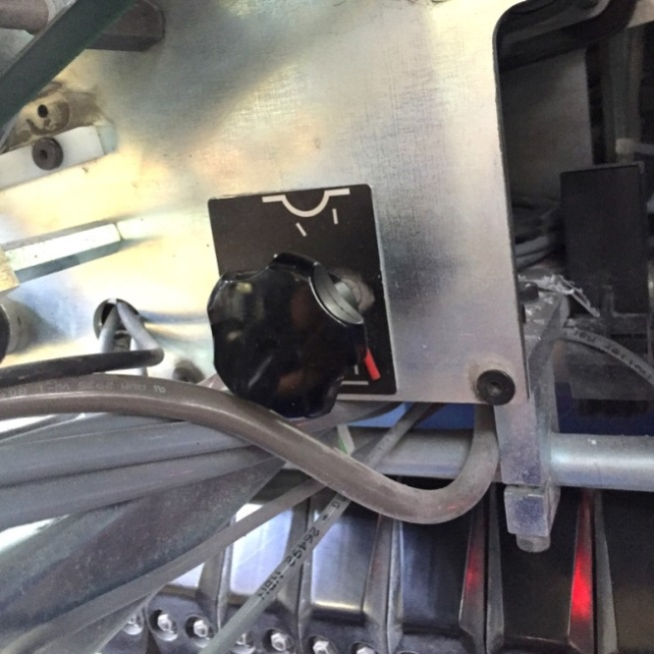
Loosen the black knob and adjust the pressure to the minimum position and retighten.

IMPORTANT

It is important to make sure the female creasing tool is aligned exactly with the centre of the creasing matrix. You may have to use different thicknesses of spacer washers to get the female aligned perfectly. Once this has been achieved the setting will not be altered again as all the colour coded females will fit the centre of the matrix crease line automatically.

